

First to Market
TRAINING MANUAL

Welcome to <<Company Name>>!

<<Company Name>> Vision Statement

<<Company Name>> Core Values

- Authenticity
- Compassion
- Honesty
- Wisdom
- Diligence
- Community

Wholesaling 101

What is Wholesaling Real Estate?

Wholesaling is the process of getting a Real Estate Property under a purchase contract at a steep discount, usually because of some sort of distress, and re-selling it to another investor before the purchase agreement expires. In Real Estate Wholesaling, we do not sell the property, but instead, we are selling the purchase and sales agreement for a fee.

The Six Major Steps of a Wholesale Transaction

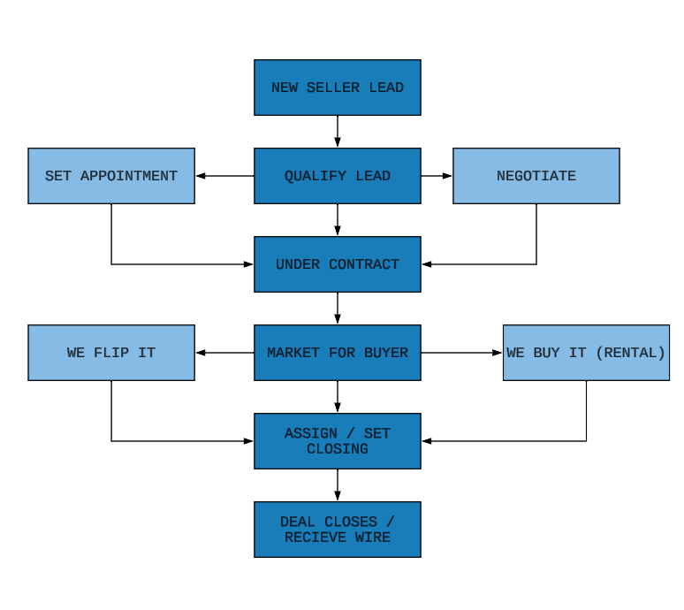

What is First To Market?

Data Manager Position

Summary of Process

Responsibilities of a Data Manager

Daily

Weekly

Monthly

Quarterly

Why is pulling data important?

Where are the locations that data can be pulled from?

The Lists We Pull

- A
- B
- C
- D

How to login

Pulling List A

Pulling List B

Pulling List C

Pulling List D

Building the CSV Document

Uploading PROSPECTS into REISift

Skiptracing New Records

Niche Prospector Position

Our goal is to train you to be the best all around Niche Prospector you can be.

Summary of Process

Responsibilities of a Niche Prospector

Daily

Weekly

Monthly

Quarterly

The Niche Prospector Role in the Sales Process

Niche Prospector Marketing Flow

Niche Prospector KPI tracking

After dialing through the list and document using the extension “Tally Counter” you extract all, open the excel sheet and copy the results then paste them in the KPI Tracker below >>

KPI Tracker:
https://docs.google.com/spreadsheets/d/1pYAfb5egpwv55rJFtCNPcUGgZjUPfujCVWCvGiQ7h8I/copy

Keys to Success

Core Expectations

